1. Process: Admission Process
2. Purpose: Register students and their courses
3. Screens in this process

|  |  |  |
| --- | --- | --- |
| **Screen Name** | **Purpose** | **Access By User Role** |
| Register Students | Register new students | Education in charge |
| View Student/Application List | View admission list and confirm/cancel admission | College AD or Education in charge |
| Confirm Student Admission | Confirm student admission | College AD |
| Cancellation of Admission | Cancel student admission | College AD |
| Register/Authorize Student Courses | Register student courses | ourse Advisor |
| Print Student Course Registration Form | Print Roster form (student courses) | Course Advisor or Education in charge |
| Print Categorywise Admission Summary | Print report Category-wise admission summary | College AD |
| Print Categorywise Student List | Print report Category-wise admission list | College AD |
| Print Semesterwise Course Student Summary | Print report semester-wise course student summary | College AD |
| Allot Enrollment Nos | Allot enrollment numbers | UNIV DR |
| Print New Student Enrolment Report | Print report new student enrollment | College AD or UNIV DR |
| Apply for Next Semester Admission/Transfer student | After finishing one semester, admit students to next semester | Education in charge |

1. **Screen:**

**4.1 Login Screen:**

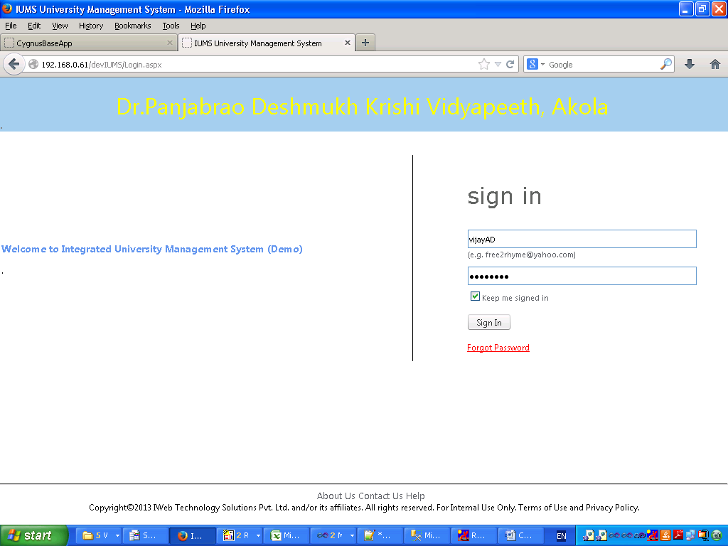

**4.2 Student Registration (Screen 1 – Basic Profile)**

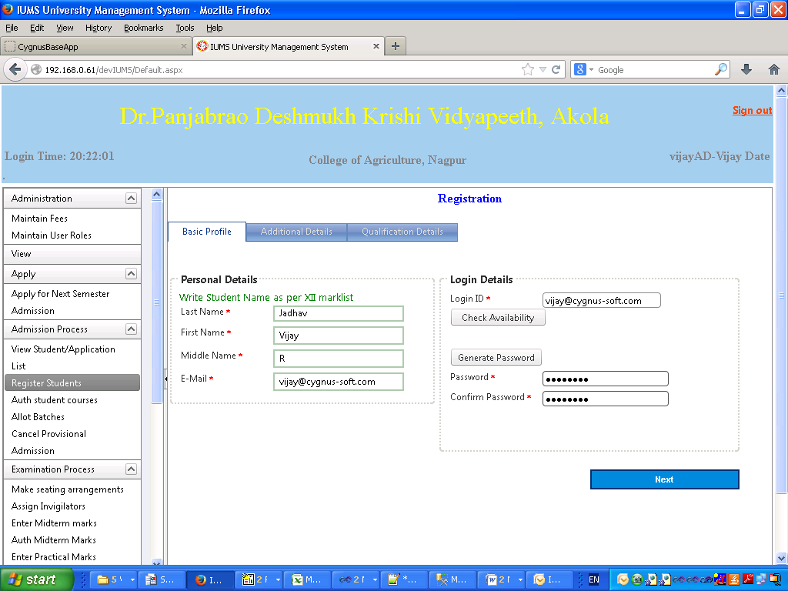

Screen Operation: Enter all mandatory fields. Click on the Next button will take you to the next screen for registration – Additional Details.

Basic Profile (Personal Details)

|  |  |  |  |
| --- | --- | --- | --- |
| **Field Name** | **Description** | **Mandatory/Optional** | **Validation** |
| Last Name | Enter last name of the student | Mandatory | Alphanumeric |
| First Name | Enter first name of the student | Mandatory | Alphanumeric |
| Middle Name | Enter middle name of the student | Mandatory | Alphanumeric |
| Email | Enter email address of the student | Mandatory | Valid email address |

Basic Profile (Login Details)

|  |  |  |  |
| --- | --- | --- | --- |
| **Field Name** | **Description** | **Mandatory/Optional** | **Validation** |
| Login ID | Enter a login id of this student, by default the email address will be copied here | Mandatory | Alphanumeric |
| Check Availability | Click this button to check if the login id is available in the system | Optional | Click only |
| Password | Enter password for this student | Mandatory | Alphanumeric minimum 8 characters maximum 18 characters |
| Generate Password | Click this button to generate a random password for this student | Optional | Click only |
| Confirm Password | Enter the password once again to confirm | Mandatory | Same as password |

**4.3 Student Registration (Screen 2 – Upper half)**

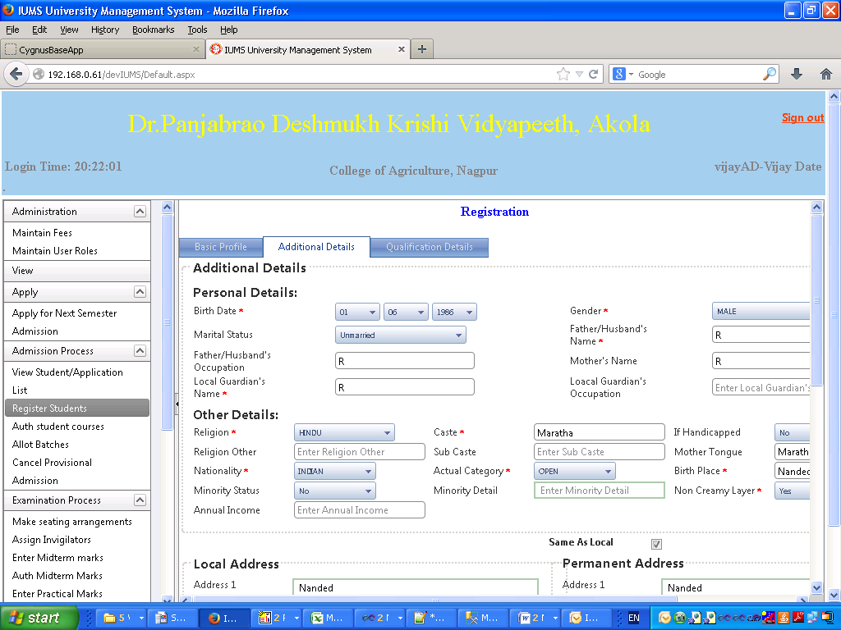

Screen Operation: Enter all the mandatory fields. Enter optional fields if necessary. Click on the Next button to go to the next screen of student registration – qualification details.

Personal Details

|  |  |  |  |
| --- | --- | --- | --- |
| **Field Name** | **Description** | **Mandatory/Optional** | **Validation** |
| Birth Date | Enter Birth Date of the student | Mandatory | Date |
| Gender | Select gender of the student from the dropdown | Mandatory | Selection only |
| Marital Status | Select marital status from dropdown | Mandatory | Select only |
| Father’s/Husband’s Name | Enter father’s name or husband’s name | Mandatory | Alphanumeric |
| Father’s/Husband’s Occupation | Enter Father’s or Husband’s Occupation | Optional | Alphanumeric |
| Mother’s Name | Enter mother’s name | Optional | Alphanumeric |
| Local Guardian’s Name | Enter Local Guardian’s | Mandatory | Alphanumeric |
| Local Guardian’s Occupation | Enter Local Guardian’s Occupation | Optional | Alphanumeric |

Other Details

|  |  |  |  |
| --- | --- | --- | --- |
| **Field Name** | **Description** | **Mandatory/Optional** | **Validation** |
| Religion | Select religion from dropdown | Mandatory | Select only |
| Caste | Enter caste of the student | Mandatory | Alphanumeric |
| Is Handicapped | Select yes/no from dropdown | Mandatory |  |
| Religion Other | If the religion is not present in the dropdown, select Other and input the religion name here | Optional | Alphanumeric |
| Sub caste | Enter sub caste of the student | Optional | Alphanumeric |
| Mother tongue | Enter Mother tongue |  |  |
| Nationality | Select Nationality from dropdown | Optional | Select only |
| Actual Category | Select actual reservation category of the student from dropdown | Mandatory | Select only |
| Birth Place | Enter Birth Place of the student | Mandatory | Alphanumeric |
| Minority Status | Select minority status from dropdown | Optional | Select only |
| Minority Detail | Enter specific religion of student if Minority | Optional | Alphanumeric |
| Non creamy Layer | Select Yes/No from dropdown | Mandatory | Select only |

**4.4 Student Registration (Screen 2 - Lower Half)**

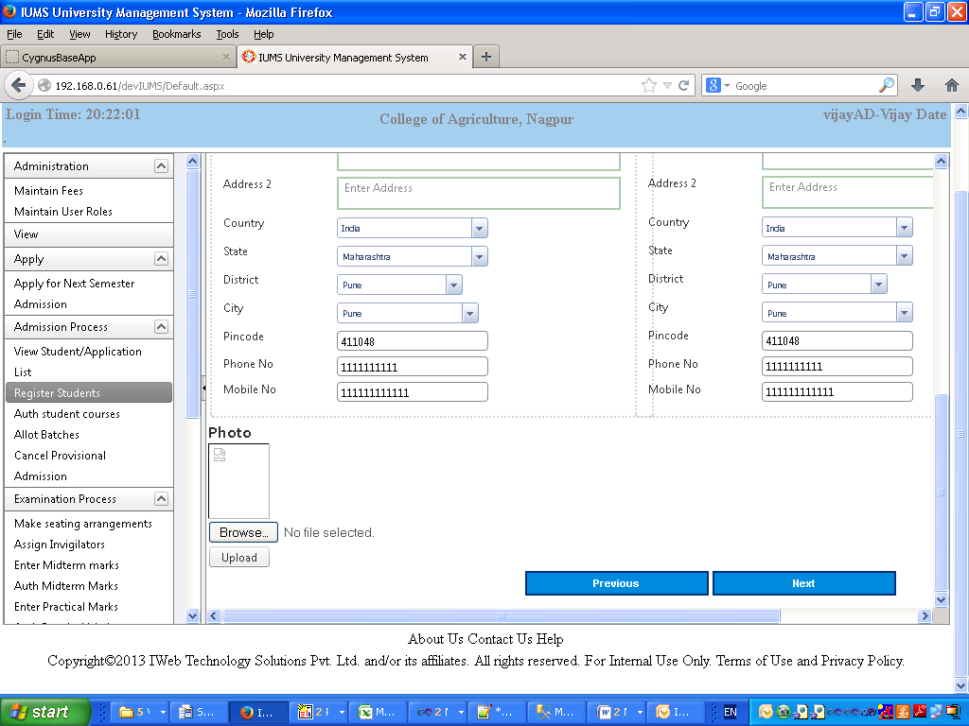

Local Address

|  |  |  |  |
| --- | --- | --- | --- |
| **Field Name** | **Description** | **Mandatory/Optional** | **Validation** |
| Address 1 | Enter 1st line of address | Optional | Alphanumeric |
| Address 2 | Enter 2nd line of address | Optional | Alphanumeric |
| Country | Select country from dropdown | Optional | Select only |
| State | Select state from dropdown | Optional | Select only |
| District | Select district from dropdown | Optional | Select only |
| City | Enter City | Optional | Alphanumeric |
| Pin code | Enter pin code | Optional | Alphanumeric |
| Phone Number | Enter phone number of the student | Mandatory | Numeric |
| Mobile Number | Enter mobile number of the student | Mandatory | Numeric |

Permanent Address

|  |  |  |  |
| --- | --- | --- | --- |
| **Field Name** | **Description** | **Mandatory/Optional** | **Validation** |
| Same as Local | Check the checkbox if permanent address is same as local | Optional | Check only |
| Address 1 | Enter 1st line of address | Optional | Alphanumeric |
| Address 2 | Enter 2nd line of address | Optional | Alphanumeric |
| Country | Select country from dropdown | Optional | Select only |
| State | Select state from dropdown | Optional | Select only |
| District | Select district from dropdown | Optional | Select only |
| City | Enter City | Optional | Alphanumeric |
| Pin code | Enter pin code | Optional | Alphanumeric |
| Phone Number | Enter phone number of the student | Mandatory | Numeric |
| Mobile Number | Enter mobile number of the student | Mandatory | Numeric |

|  |  |  |  |
| --- | --- | --- | --- |
| Photo | Browse & select the photo image file. Click Upload button. | Optional | JPG image file of size < 100KB |

**4.5 Student Registration (Screen 3 - Upper Half)**

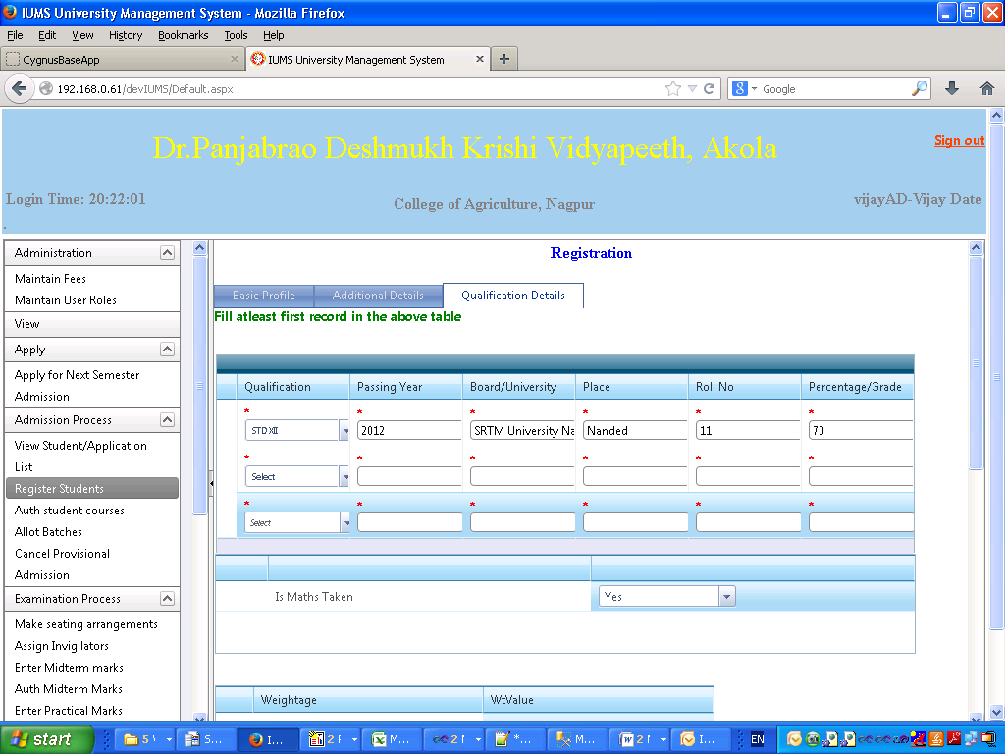

Screen Operation: This screen is used to enter the student’s academic qualification details. It is mandatory to fill in at least 1 record in the table. Select Yes/No for the “Is Maths Taken” question.

Then Check the checkboxes of the Weightages applicable to the student. Select all other Admission details and click on Register button to save.

|  |  |  |  |
| --- | --- | --- | --- |
| **Field Name** | **Description** | **Mandatory/Optional** | **Validation** |
| Qualification | Select qualification from dropdown | Mandatory | Select only |
| Passing Year | Enter year of passing | Mandatory | Numeric |
| Board/University | Enter name of board or university which conducted the exam | Mandatory | Alphanumeric |
| Place | Enter the name of the place where Board/University is located | Mandatory | Alphanumeric |
| Roll No. | Enter exam roll no. of the student | Mandatory | Alphanumeric |
| Percentage/Grade | Enter percentage or grade obtained by student |  | Numeric |

**4.6 Student Registration (Screen 3 - Lower Half)**

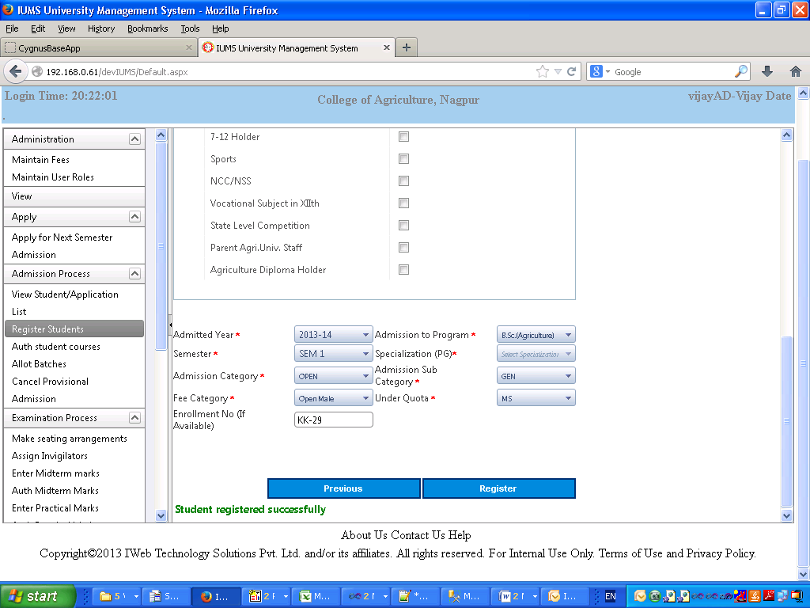

|  |  |  |  |
| --- | --- | --- | --- |
| **Field Name** | **Description** | **Mandatory/Optional** | **Validation** |
| Admitted Year | Select the year of admission from dropdown | Mandatory | Select only |
| Admission to Program | Select the program from dropdown | Mandatory | Select only |
| Semester | Select semester from dropdown in which student is currently admitted. | Mandatory | Select only |
| Specialization (PG only) | Select Specialization from dropdown | Mandatory | Select only |
| Admission Category | Select Constitutional Reservation Category from dropdown | Mandatory | Select only |
| Admission Subcategory | Select Parallel Reservation Category from dropdown | Mandatory | Select only |
| Fee Category | Select semester from dropdown | Mandatory | Select only |
| Under Quota | Select semester from dropdown | Mandatory | Select only |
| Enrollment No. | Enter the enrollment no. of student if already given | Optional | Alphanumeric |

**4.7 View Student/Application List**

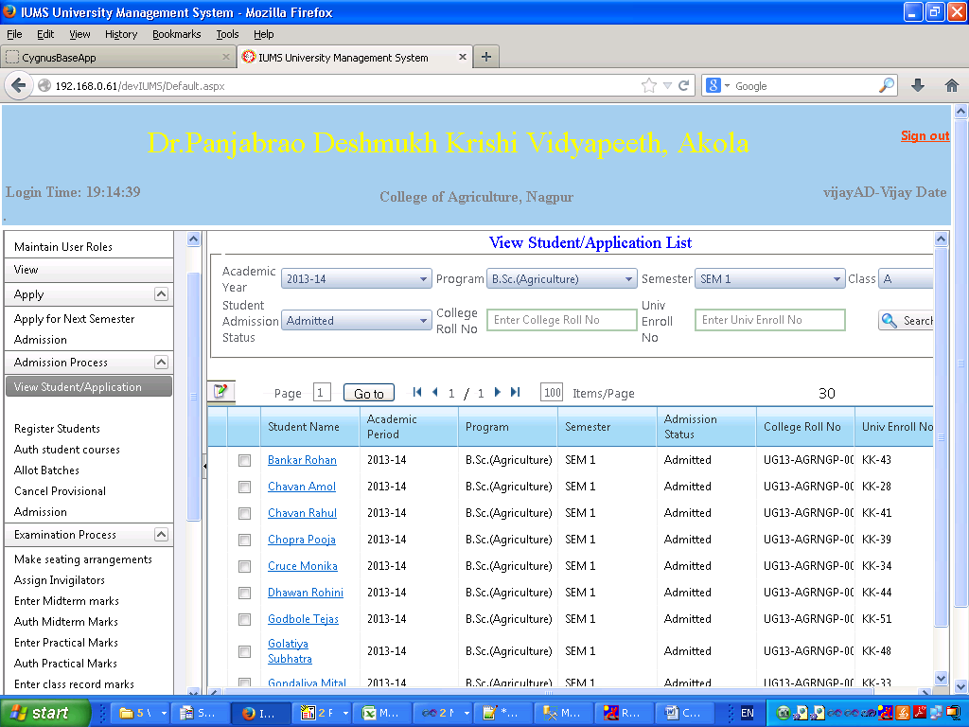

Screen Operation: Select any one of Academic year, Program, Semester, Admission Status. If you know the specific student’s roll no. or enrollment number you may enter it. Click on Search button.

The list of students matching with the selected criteria will be displayed in the grid below. Click on the hyperlink of student name to go to the next screen for confirming or cancelling admission.

**4.8 Confirm Student Admission (Upper Half)**

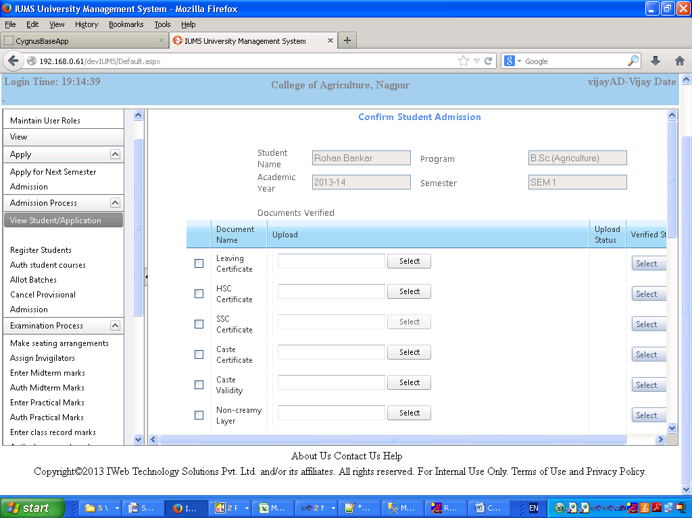

Screen Operation: This screen is displayed when Student Name hyperlink is clicked in the View Student/Application list screen.

The name of the student, program, academic year, semester are all displayed for the selected student.

In the Documents Verified section, check the check box for the documents which the student has submitted.

If you have the scanned image of the document, then click Select button, select the file of the image and upload the file. The name of the uploaded file will be displayed.

After verifying the document, select Yes/No from the Verified Status dropdown.

**4.9 Confirm Student Admission (Lower Half)**

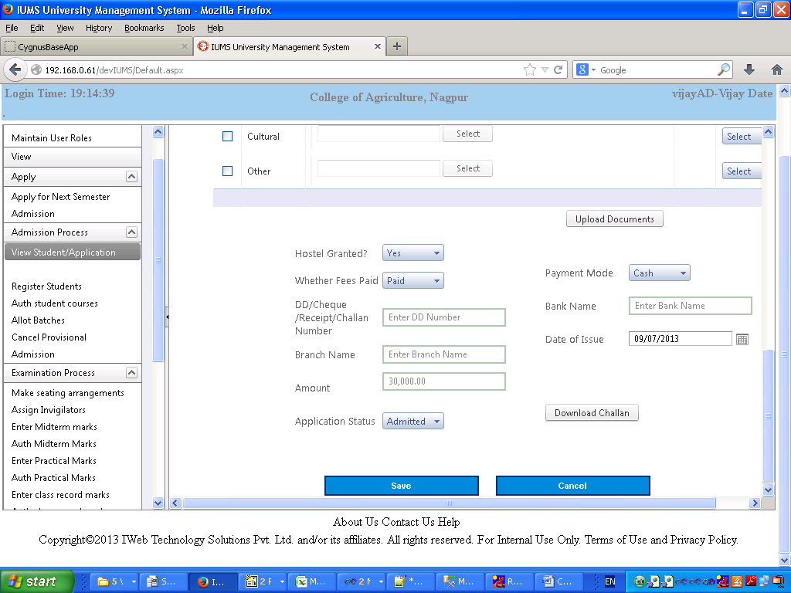

Screen Operation: Select all the dropdown fields and enter data in the textbox fields. Click on the Save button to save the data. A message “Data saved successfully” will be displayed.

Field Details

|  |  |  |  |
| --- | --- | --- | --- |
| **Field Name** | **Description** | **Mandatory/Optional** | **Validation** |
| Hostel Granted | Select Yes/No from dropdown | Mandatory | Select only |
| Whether Fees Paid | Select Yes/No from dropdown | Mandatory | Select only |
| Payment mode | Select payment mode from dropdown | Optional | Select only |
| DD/Cheuqe/Receipt No. | Enter the DD/Cheque/Receipt number | Optional | Alphanumeric |
| Bank Name | Enter Bank name | Optional | Alphanumeric |
| Branch Name | Enter Branch name | Optional | Alphanumeric |
| Date of Issue | Enter Date of Issue | Optional | Date |
| Amount | Enter amount | Optional | Numeric |
| Application Status | Select application status from dropdown – Initial status is Applied. Change to Admitted or Cancelled | Optional | Select only |
| Download Challan | Click to download challan | Optional | Button click only |

**4.10 PG Register/Auth. Student Courses & View PG Student list**

Click on PG Annexure- select academic year, Program etc. and Click on search button for view student list.

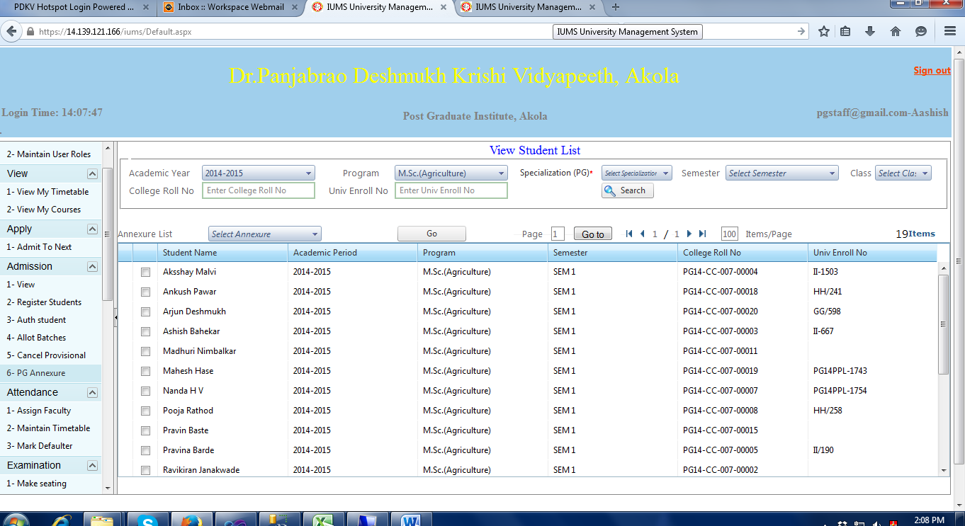

Select Student & then Select Annexure from annexure list & click on GO button for open PG Student course Registration screen.

**4.11 PG Register/Auth. Student Courses (upper half)**

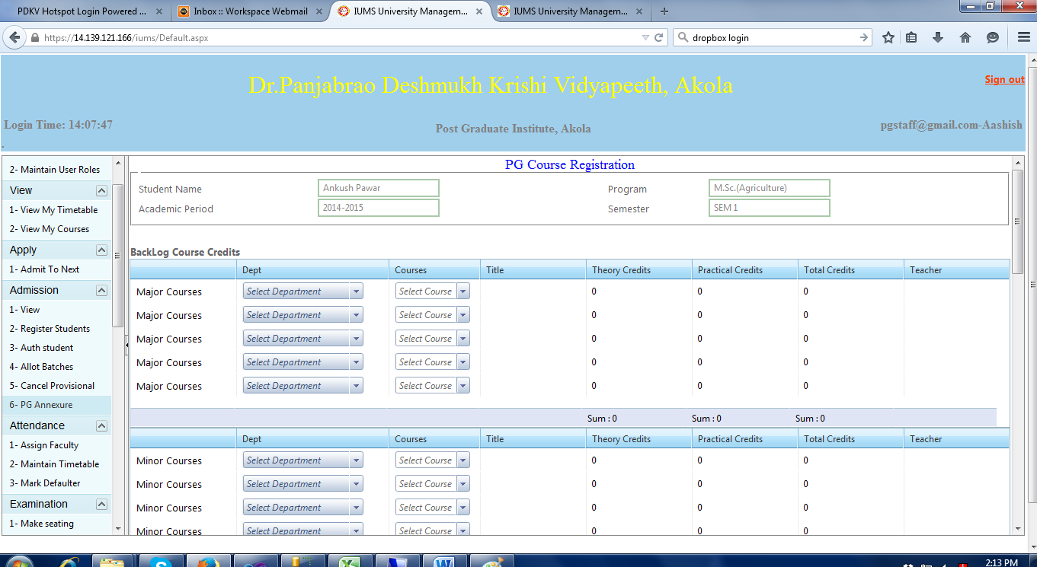

Select department wise major courses & minor courses –then display Title, theory credits, practical credits, total credits & teacher.

**4.12 PG Register/Auth. Student Courses (Middle half)**

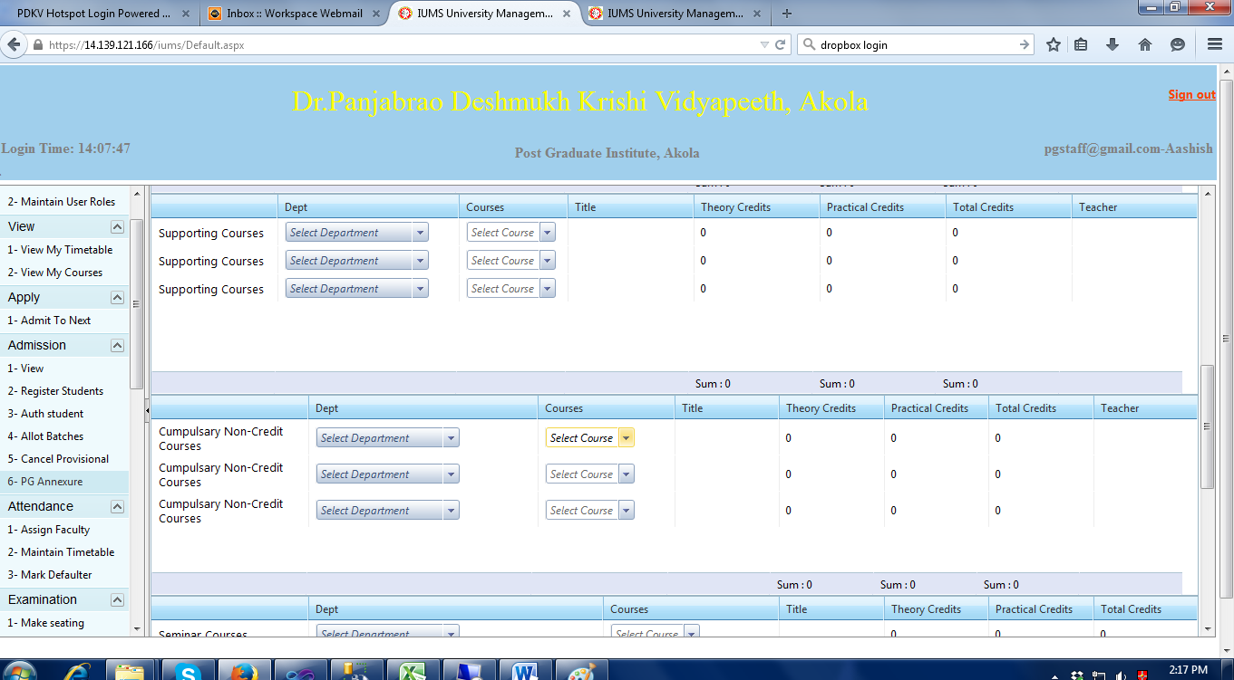

Select department wise supporting courses & compulsory non-credit courses -- then display Title, theory credits, practical credits, total credits & teacher.

**4.13 PG Register/Auth. Student Courses (Lower half)**

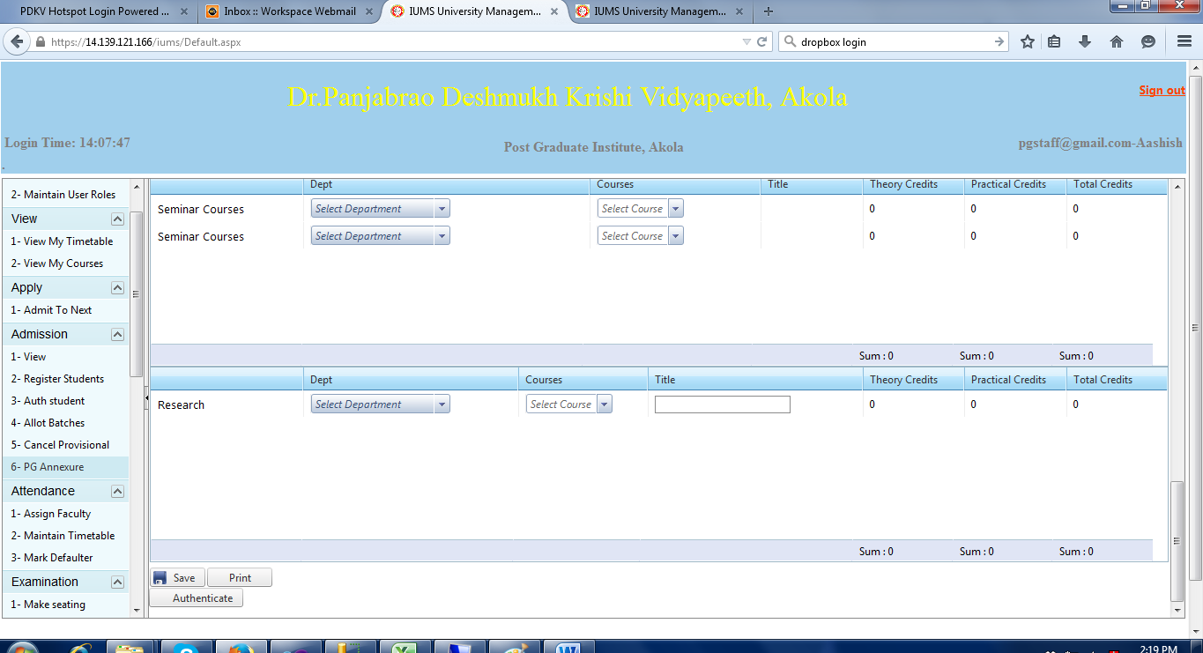

Select department wise seminar courses & Research -- then display Title, theory credits, practical credits, total credits & teacher. Click save button to save the data. A message “Data saved successfully” will be displayed. & click on Print button for list of registered courses and click on authenticate button to authenticate courses.

**4.12 Cancellation of Admission**

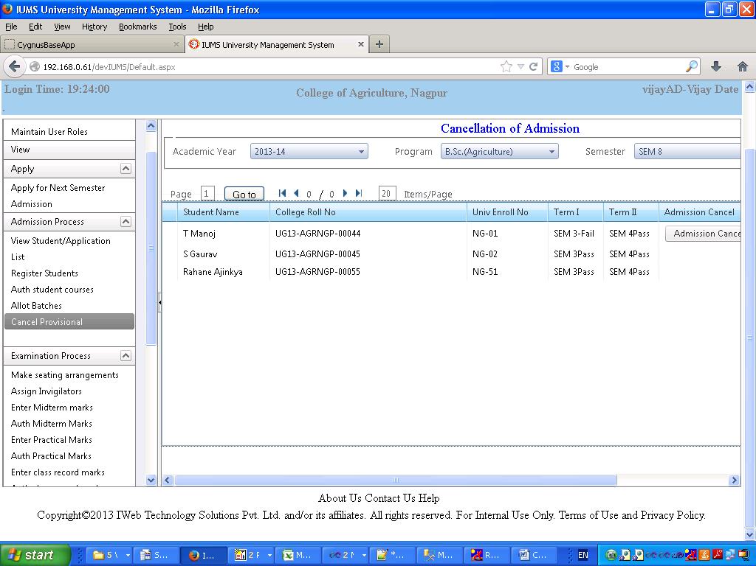

Screen Operation: This screen is used to cancel the Provisional admission given to students who fail to clear their backlog exams as per the rules. For example, admission will be cancelled for students who fail to clear Semester 1 courses but have been admitted to Semester 5 provisionally.

Select academic year, program and semester. Click Search button. List of students admitted in the selected semester will be displayed along with the Result of their previous qualifying semester (1st year for 3rd year, 2nd year for 4th year and so on). Only for the students who have failed, a button “Admission Cancel” button will be displayed. Click on the button to cancel the student’s admission.

**4.13 Print Student Course Registration Form (Upper half)**

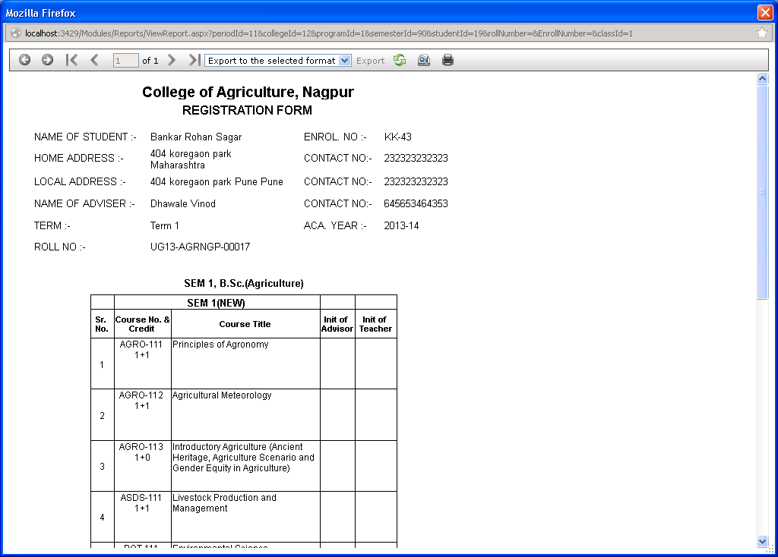

Screen operation: This is the output of the report that is generated after selecting the specific student. Click on the Print button to print the report.

**4.14 Print Student Course Registration Form (Lower half)**

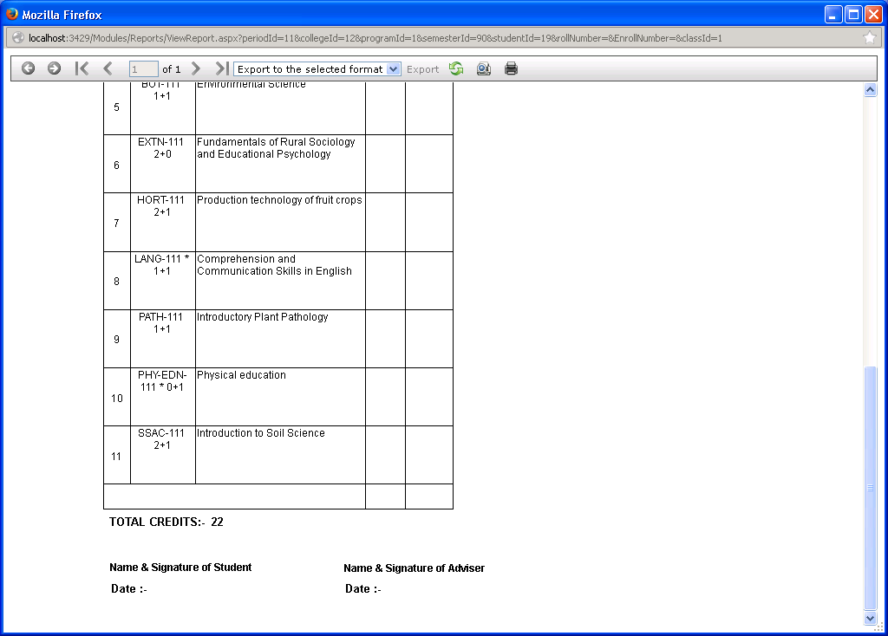

**4.15 Print Categorywise Admission Summary**

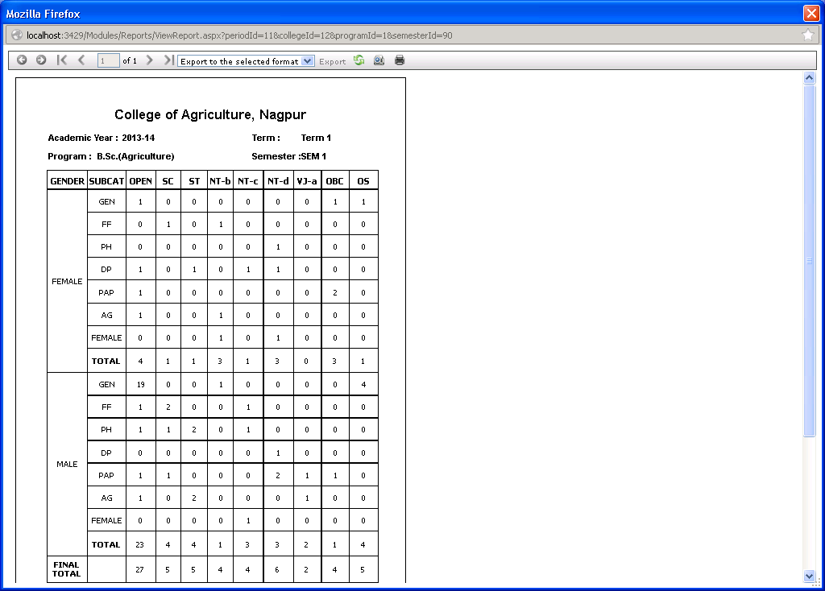

Screen Operation:

**4.16 Print Categorywise Student List**

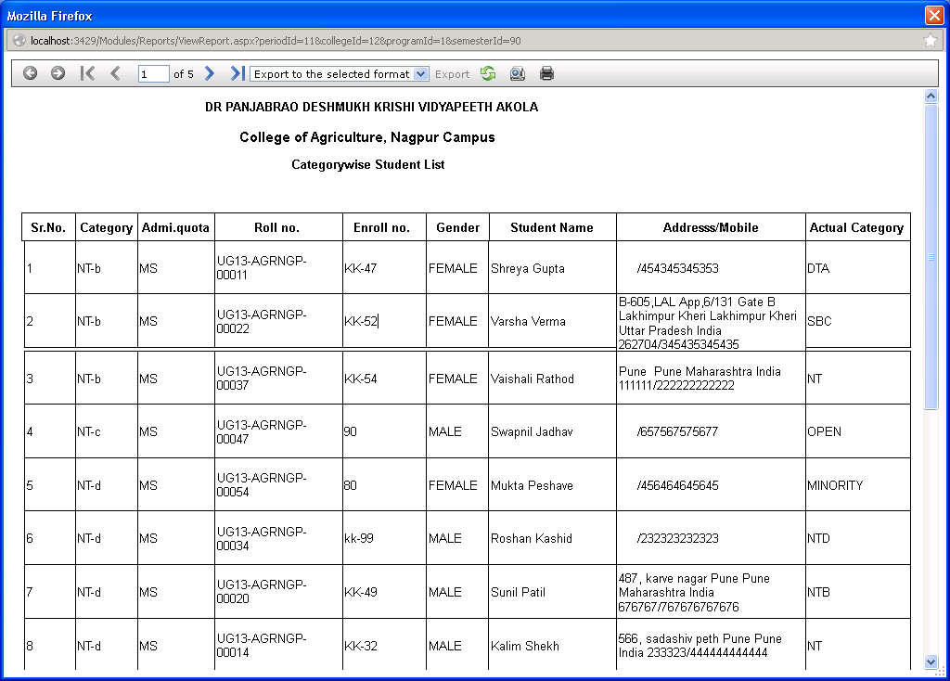

**4.17 Print Semesterwise Course Student Summary**

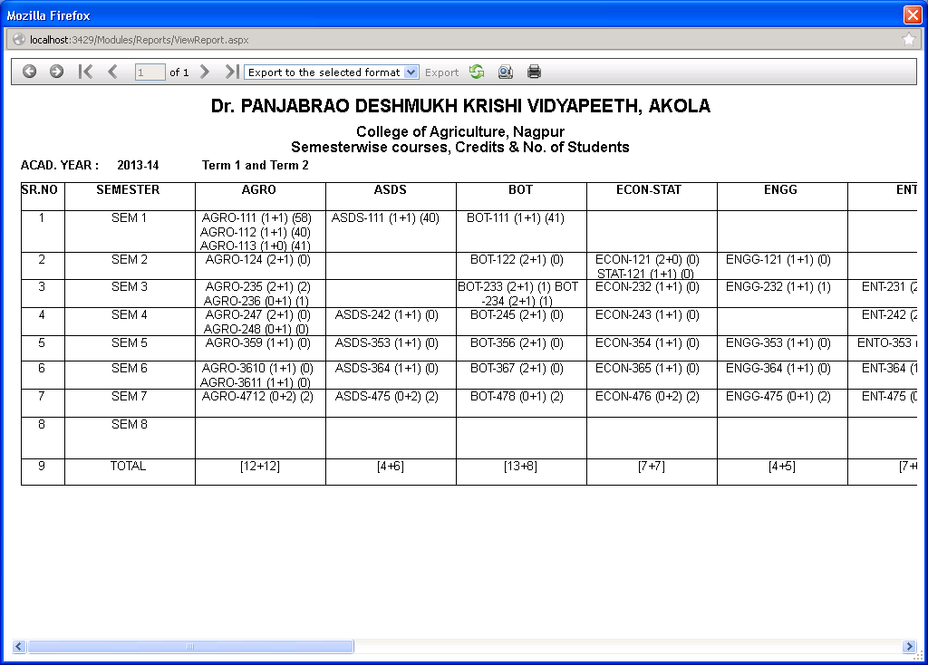

4.18 Allot Enrollment Nos.

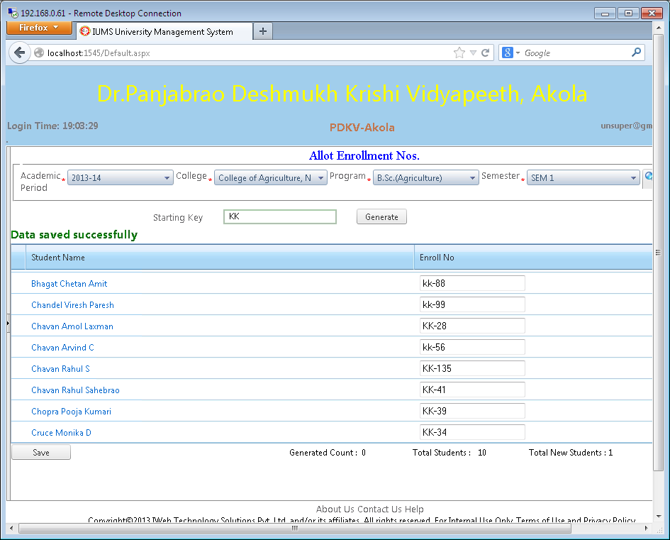

Screen Operation: Select Academic year, College, Program and Semester. Click Search button. The list of students in the selected program/college/semester will be displayed. If the enrollment no. is already allotted to the student, it will be displayed otherwise blank will be displayed.

Enter Starting Key which is the series for generating enrollment number for each year. Click on Generate button. The students who have blank enrollment numbers, will be filled with sequential enrollment numbers of the given series. If the same starting Key has been used before, the enrollment numbers will start from the last number given in the series. Otherwise it will start from 1.

Click on Save button to update the students records with this enrollment no.

4.19 Print New Student Enrolment Report

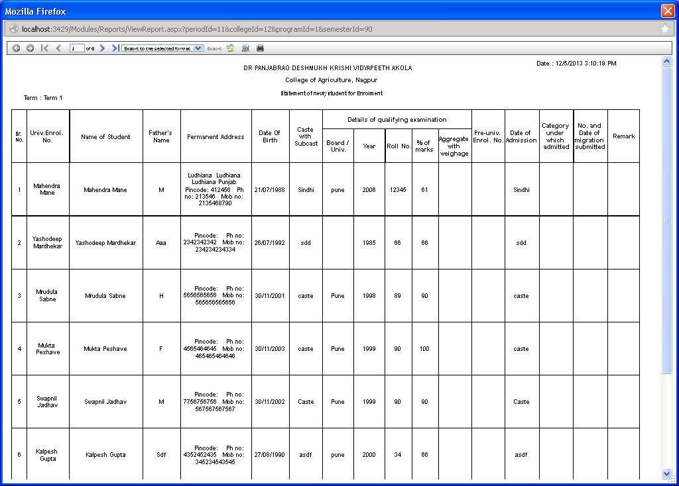

4.20 Apply for Next Semester Admission

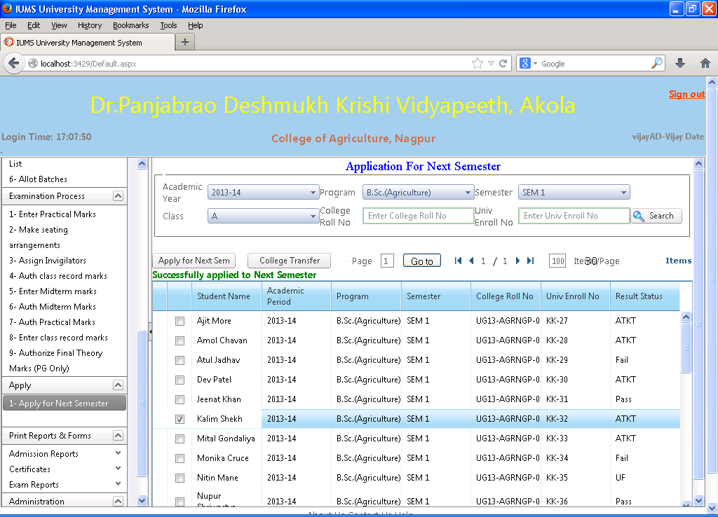

Screen Operation: Select academic year, program, semester and class. Or if you know the specific student’s roll no. or enrolment no. , enter it. Click Search button.

The list of students matching the given criteria will be displayed. Click the checkbox against the student name which you want to promote to next semester. Click on the “Apply to Next Semester” button.

The system will automatically create the application of the selected student for the next semester. After this it will have to be confirmed as per Admission Confirmation procedure given initially in this manual.

This screen is also used to transfer a student from one college to another. After displaying the list of students, check the checkbox against the student name. Click on the College Transfer button. Then select the new college from the college dropdown. Click Save button to confirm the student’s transfer to another college.